BOARD OF TRUSTEES

CLOUD COUNTY COMMUNITY COLLEGE

September 29, 2015

MISSION

Cloud County Community College is dedicated to delivering high quality, innovative, affordable, and accessible educational opportunities and services that prepare a diverse population to be critical thinkers and lifelong learners who can meet the challenges of an ever-changing global community.

To assure the delivery of this mission, Cloud County Community College is directed by valid and reliable assessment techniques, which measure the effectiveness and efficiency of all departments in the delivery of curriculum and services in support of student academic success.

VISION

Cloud County Community College strives to enrich the lives of our students and the communities we serve.

CLOUD COUNTY COMMUNITY COLLEGE
BOARD OF TRUSTEES

AGENDA - September 29, 2015

Meeting Place: Room 257 in the President’s Addition
Time: 7:00 p.m.

1. Call to Order – 7:00 p.m.

2. Adopt Agenda

3. Guests’ Comments

4. Recognitions

5. Consent Agenda . Information

- Approval of Minutes of August 25, 2015 and September 9, 2015
- Treasurer’s Report
- Purchasing and Payment of Claims
D. Personnel

6. Reports

A. President’s Message
B. Vice President for Academic Affairs
C. Vice President for Administrative Services
D. Vice President for Student Services and Development
E. Geary County Campus Update
F. Meetings Trustees Attended

7. Discussion Items

A. Wayfinding Signage Project – Concordia Campus

8. Action Items

- Policy E2 - Admissions and Policy F28 – Institutional Review Board (IRB) for Treatment of Human Subjects
- Policy D3 – Grades and Grading
- Policy D4 – Attendance
- Program Review Manual
- 2015-2020 Strategic Goals
- Sublease Extension for Building “D” – Geary County Campus
9. Other

10. Executive Session

A. Negotiations
B. Consultation with Legal Counsel
C. Non-elected Personnel

NEXT MEETING – October 27, 2015

CLOUD COUNTY COMMUNITY COLLEGE
BOARD OF TRUSTEES
September 29, 2015

ITEM NO: 1

AGENDA ITEM: Call to Order – 7:00 p.m.

ITEM TYPE:

COMMENT:

CLOUD COUNTY COMMUNITY COLLEGE
BOARD OF TRUSTEES
September 29, 2015

ITEM NO: 2

AGENDA ITEM: Adopt Agenda

ITEM TYPE: Decision

COMMENT:

Parliamentary rules recommend the adoption of the Agenda.

RECOMMENDED ACTION:

Adopt the Agenda for the September 29, 2015 Board of Trustees meeting.

CLOUD COUNTY COMMUNITY COLLEGE
BOARD OF TRUSTEES
September 29, 2015

ITEM NO: 3

AGENDA ITEM: Guests’ Comments

ITEM TYPE:

COMMENT:

CLOUD COUNTY COMMUNITY COLLEGE
BOARD OF TRUSTEES
September 29, 2015

ITEM NO: 4

AGENDA ITEM: Recognitions

ITEM TYPE:

COMMENT:

CLOUD COUNTY COMMUNITY COLLEGE
BOARD OF TRUSTEES
September 29, 2015

ITEM NO: 5

AGENDA ITEM: Consent Agenda

ITEM TYPE: Decision

COMMENT:

- Approval of Minutes of August 25, 2015 and September 9, 2015. The minutes of the regular meeting of August 25, 2015 and the special meeting of September 9, 2015 are enclosed.

- Treasurer’s Report. The Treasurer’s Report as of August 31, 2015 shows a balance of $8,412,541.00 at Central National Bank.

- Purchasing and Payment of Claims. The purchase orders are enclosed or are available from the Clerk of the Board.

- Personnel.

RECOMMENDED ACTION:

Approve the items included in the Consent Agenda as presented.

CLOUD COUNTY COMMUNITY COLLEGE
BOARD OF TRUSTEES
September 29, 2015

(A) LIST
APPROVAL OF EXPENDITURES OR TRANSFERS OF COLLEGE FUNDS OVER $10,000.
This list contains requests for approval of expenditures or transfers of college funds over $10,000.
For some of the items listed, checks will be released prior to the next Board meeting and approval
of this list by the Board at this meeting will also authorize release of the checks. The other items,
orders will be prepared, and the payment of claims will be approved at the next Board meeting.

- 01-34-2010-796 CCCC TRiO Indirect Funds 15-16 $ 17,118.74
2. 01-34-2010-516 CCCC TRiO Fringe Benefits (Sept-Dec) 15,139.19

3. 01-73-7303-799 Turnitin Renewal for add-on to Canvas to 10,531.20
enhance student learning

4. 01-85-9100-741 Consolidated Management Meals – 8-13 to 9-9 43,296.00

5. 01-11-6200-663 Jarred Gilmore Phillips Audit of Records 11,000.00

6. 01-73-7303-799 The College Board Annual Power Faids Support 13,032.00

CLOUD COUNTY COMMUNITY COLLEGE
BOARD OF TRUSTEES
September 29, 2015

ITEM NO: 6

AGENDA ITEM: Reports

ITEM TYPE: Information

COMMENT:

A. President’s Message.

1) Sophomore Career Day

2) Glasco Fun Day

3) Fall Play

4) Family Weekend

B. Vice President for Academic Affairs.

C. Vice President for Administrative Services.

- Financial Overview

2) Facilities

3) Tickets

D. Vice President for Student Services and Development.

E. Geary County Campus Update. A report from the Geary County Campus is enclosed.

CLOUD COUNTY COMMUNITY COLLEGE
BOARD OF TRUSTEES
September 29, 2015

ITEM NO: 6

AGENDA ITEM: Reports (Cont’d)

ITEM TYPE: Information

COMMENT:

F. Meetings Trustees Attended.

Geary County Campus
Report to the Board of Trustees
September 29, 2015

This report highlights the recent activities of the offices of the Associate Vice-President, Coordinator of Student Services, and Director of Business and Industry Programs.

Campus Activities – Brenda Edleston, Associate Vice President
- Geary County Campus faculty and staff have been working closely with Josh Engelbert to trouble-shoot their IT concerns in the interim while the College conducts its search to fill the IT Specialist position for the Campus.
- Brenda Edleston is in the process of developing the Spring 2016 and Summer 2016 class schedules.
- Edleston is updating the strategic plans for the Geary Campus and will provide a report to the Trustees at their October meeting.
- In conjunction with the Kansas Community College Leadership Institute, Edleston had the opportunity to interview Dr. Toone and Board Chair Ellen Anderson concerning matters of expectations, communications, accomplishments, and working relations. Each KCCLI participant will share their findings at the upcoming session October 1 and 2 at Kansas City Kansas Community College.
- Edleston worked with Amy Lange to write a sublease extension for Building “D” on the Geary Campus. This lease, when approved by the Board of Trustees, will be presented by Edleston to the Geary County Commissioners.
- Brenda is in the process of obtaining quotes to replace the campus sign in front of the Russell Johnson Administration Building. The design will mirror that of the larger monument sign located on the corner of Ash and Caroline streets.
- Edleston and Dr. Mitch Stimers will be accompanying the team from Concordia to the American Association of Community Colleges sponsored High Performance Team Building training in Houston, September 21-24.
- The Concordia and Geary chapters of Phi Theta Kappa two-year college honor society will hold a joint induction of new members on Friday, September 25, in Cook Theater.
- Saturday, September 26, volunteers from the Geary Campus will be on Fort Riley promoting CCCC at the annual Apple Day celebration.
- Edleston is serving on the selection committee to fill the open position for the Director of Assessment and Accreditation.

Student Services Activities – Jennifer Zabokrtsky, Coordinator of Student Services
Recruitment/Admissions/Scholarships
- Ashley Ortega administered the Compass placement test to 28 prospective students, including seven Junction City HS Concurrent students, conducted 18 campus visit tours from August 14 – September 14 and visited Abilene High School September 21 to promote Cloud to prospective students.
- Jennifer Zabokrtsky emailed 67 Fall applicants who have been accepted for admission but are not enrolled in August-start classes, encouraging them to enroll in Second Start 8 week courses that begin October 19.
Financial Aid/Military Benefits
- Patti Elliott continues to travel to GCC weekly to assist Ashley Ortega in serving current and prospective students receiving military education benefits.
- Ashley Ortega pre-certified 64 Geary County Campus students for veterans’ benefits for August-start courses. Ninety-nine Cloud students are receiving VA benefits this semester.
Enrollment/Advising/Transfer
- Student Services Day for the Fall semester was August 20. Staff and faculty from GCC and Concordia were on hand to assist new and returning students with admissions, placement testing, enrollment, textbook ordering, student ID pictures, payment arrangements, financial aid and military education benefits. We netted 43 new enrollments and 426 credit hours that day.
- New Student Orientation was August 24 at 5:30 PM. Fifty-one people attended, including 34 new students and their families.
Student Retention
- Kim Wagner has processed 71 retention referrals from Geary County Campus faculty, impacting 58 different students and 119 retention referrals from online faculty impacting 83 different students, to help them resolve their barriers to success and get them actively engaged in class.
- Eight full-time GCC and five online students on academic probation, are enrolled in SS099 Personal Assessment and Planning. On-campus students meet weekly with Kim. Online students meet virtually. Both sections complete assignments through Canvas, the online learning management system.
Other
- Welcome Week was August 31-September 4. Activities included Tie-One-On Tuesday, Watermelon Wednesday and culminated with a Welcome Back BBQ on Thursday from 11-12:30 and 5-6:30.
- Jennifer Zabokrtsky is serving on the college-wide Calendar Committee, along with Brenda Edleston and Gwen Carnes.
- Student Services staff updated departmental strategic goals for 2015-17 to include:
  - Reduce percentage of P-drop students on first day of class in Fall and Spring semesters by 10%.
  - Increase percentage of credit hour enrollment that occurs April-July for Fall and October-December for Spring by 10%.
  - Target August and January enrollees (late enrollees) in 15-16 Academic Year and invite them to enroll early for next semester.
  - Invite August 15 enrollees to focus group to brainstorm ways to motivate future students to enroll early.
  - Increase percentage of new students Fall 16 and Fall 17 by 10%.
  - Increase percentage of GCC faculty who report attendance to Kim Wagner, by 10% from the prior year Fall 2016 and Spring 2017.
  - Student Services Staff will arrange to speak with individual classes on the Geary County Campus every February to promote students’ completion of the FAFSA for the upcoming school year. Goal to reach at least 25% of the on-campus classes and 75% of classes with enrollment of 15 or more students.
  - Update Admissions Counselor/Military Liaison and Administrative Assistant Jenzabar Manuals.
  - Task current, experienced work-study students in Student Services to create Student Services FAQ list and manual for future Student Services FWS students.

Business and Industry Program Highlights
- The next CDL Phase I training will be October 7, 8, 14 and 15, from 6:00-9:30 p.m., on Cloud’s Geary County Campus. CDL Phase II training (behind-the-wheel driving) is ongoing with DMV examinations scheduled at the Junction City DMV.
- Four students will complete the 16-credit hour Truck Driving Certificate Program on September 25. The remaining sessions for this year include September 28 – November 6 and November 4 – December 22.
- In cooperation with JoDee Aldridge-Ball, forty seats will be available for CNA training, which will begin in October with clinical rotations in the Junction City area.
- A Home Health Aide course will be offered in November. Cloud has not had an instructor who was approved by the State to teach this course in the Junction City region, so it will be an exciting new offering for students!
- Ten students are enrolled in the EMT course in Concordia for the Fall 2015 semester in conjunction with the Concordia Fire Department. Class sessions are held on Monday and Thursday evenings and every other Saturday, September 7 – November 23. Staff is actively working to expand Emergency Medical Services (EMS) offerings throughout Cloud’s service area.
- Twenty participants in the 2015-2016 Flint Hills Leadership Program visited Cloud’s Geary County Campus on Friday, September 4, to learn more about programs at Cloud. The group had expressed a specific interest in hearing more about Wind Energy, Truck Driving and Agri-Biotechnology. Cathy Troupe and Cindy Lamberty, conducted a lab experiment where the participants extracted DNA from a strawberry. The group loved it and will not forget about programs at Cloud!

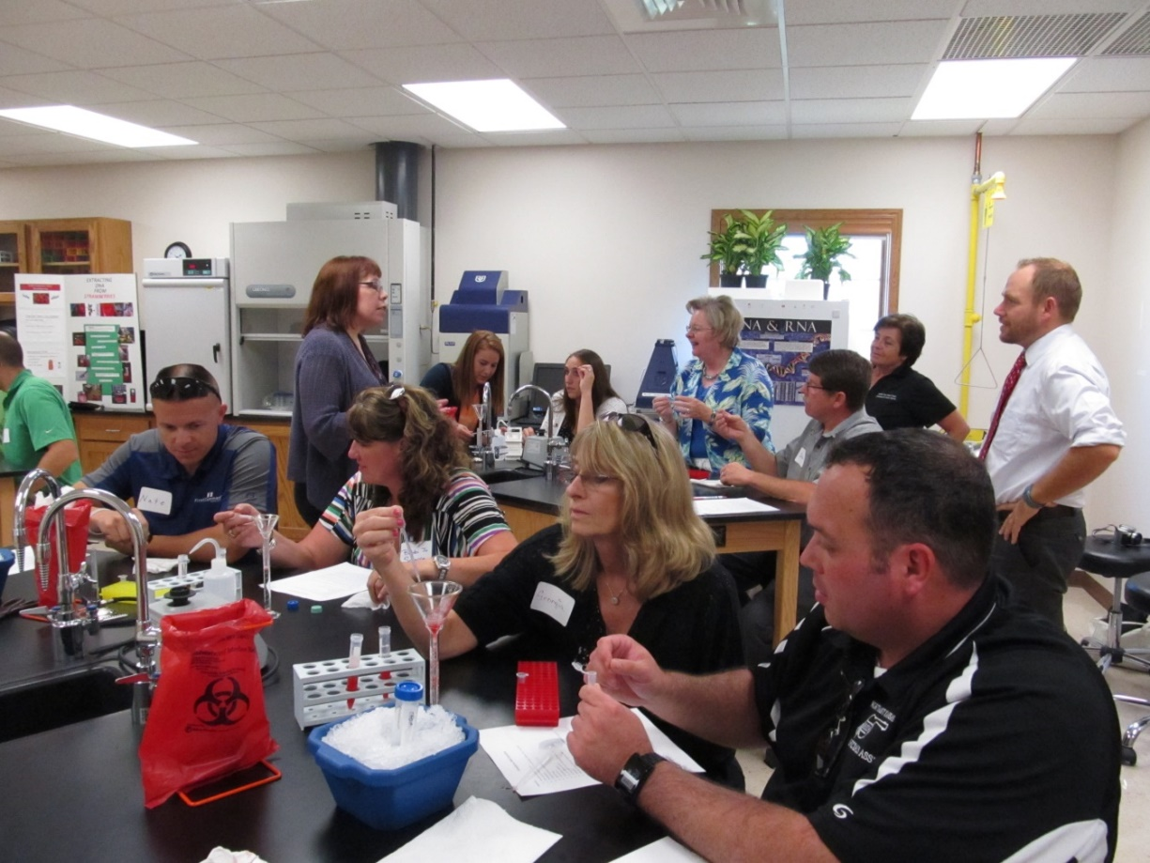

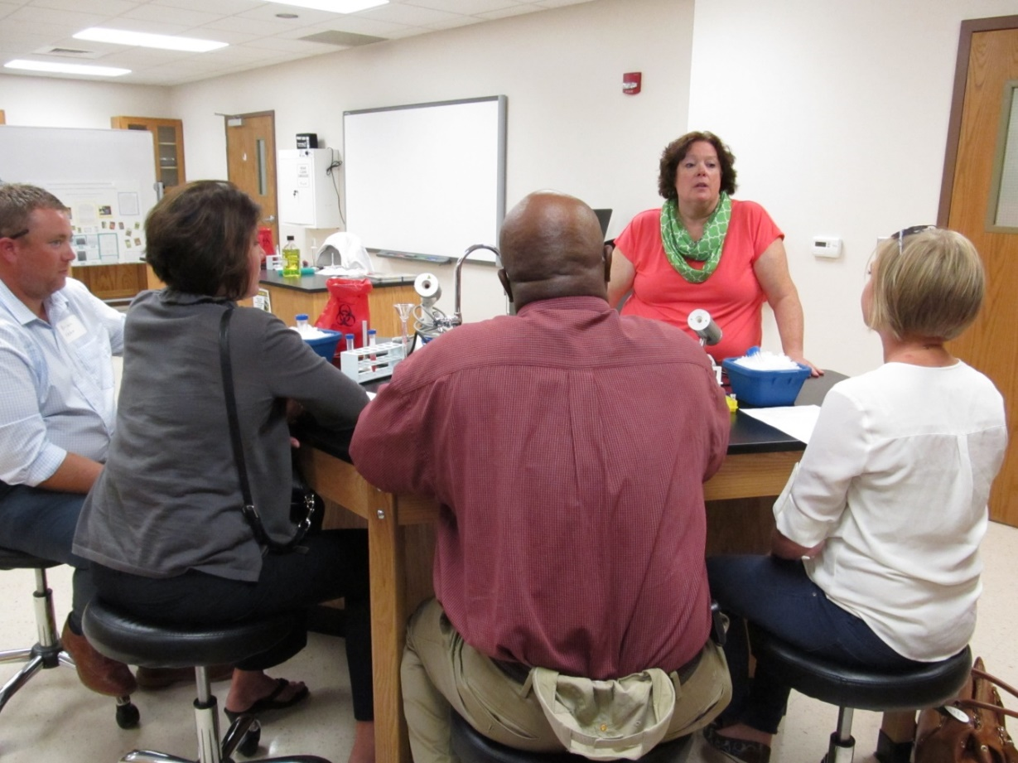

CLOUD COUNTY COMMUNITY COLLEGE
BOARD OF TRUSTEES
September 29, 2015

ITEM NO: 7

AGENDA ITEM: Discussion Items

ITEM TYPE: Discussion

COMMENT:

A. Wayfinding Signage Project – Concordia Campus. Enclosed is a summary of this project.

Memorandum

To: Board of Trustees
From: Amy Lange, Vice President for Administrative Services
Jenny Acree, Director of Marketing
Janet Eubanks, Director of Auxiliary Services
Danette Toone, President
Date: 9/29/2015
Re: Wayfinding Signage Project – Concordia Campus

The Cloud County Community College Safety Committee and the Marketing Department identified the need several years ago to improve signage on the Concordia campus for the purpose of helping college patrons find the way to their destination. The college solicited proposals for a wayfinding signage plan in 2007. While no further action was taken at that time, college staff has since used the information provided in the proposals to develop a wayfinding signage plan for the Concordia campus. This plan, which is specifically focused on exterior signage, will be presented during the Board meeting and will include visual aids.
The next step in this project is to obtain approval for a license agreement from the City of Concordia to allow the signs to be placed in the right-of-way along College Drive and Campus Drive. As you will see from the visual aids, the signs must be placed in the right-of-way in order to be effectively visible by both motorists and pedestrians. We anticipate requesting approval from the City Commission for the license agreement in October.
After receiving approval from the City Commission for a license agreement, bids will be solicited for fabrication and installation of the signs. The Board of Trustees will be asked to approve the bid for signage before the end of 2015. We anticipate completion of the project by June 30, 2015.
The college received a $50,000 grant from the Dane G. Hansen Foundation in February 2015, specifically for exterior signage. These funds will be used to purchase the signs and subsequent installation.

CLOUD COUNTY COMMUNITY COLLEGE
BOARD OF TRUSTEES
September 29, 2015

ITEM NO: 8

AGENDA ITEM: Action Items

ITEM TYPE: Decision

COMMENT:

- Policy E2 – Admissions and Policy F28 – Institutional Review Board (IRB) for Treatment of Human Subjects. At the August 25, 2015 meeting, the Board tabled action on the changes to Policy E2 - Admissions and the adoption of Policy F28 – Institutional Review Board (IRB) for Treatment of Human Subjects. These items need to be removed from the table for further discussion and action.

RECOMMENDED ACTION: Remove action on proposed Policy F28 – Institutional Review Board (IRB) for Treatment of Human Subjects from the table leaving changes to Policy E2 – Admissions on the table until the regular October meeting.

Proposed Policy F28 – Institutional Review Board (IRB) for Treatment of Human Subjects and the proposed procedures are enclosed.

RECOMMENDED ACTION: Approve adoption of Policy F28 – Institutional Review Board (IRB) for Treatment of Human Subjects.

- Policy D3 – Grades and Grading. The administration recommends a change to the procedures to this policy to include “Honor Roll”.

RECOMMENDED ACTION: Approve the changes to the procedures of Policy D3 – Grades and Grading.

CLOUD COUNTY COMMUNITY COLLEGE
BOARD OF TRUSTEES
September 29, 2015

ITEM NO: 8

AGENDA ITEM: Action Items (Cont’d)

ITEM TYPE: Decision

COMMENT:

C. Policy D4 - Attendance. The administration recommends a change to this policy clarifying practice and policy.

RECOMMENDED ACTION: Approve the changes to Policy D4 – Attendance.

D. Program Review Manual. The administration is recommending an update to the Program Review Manual. The manual with the proposed changes is enclosed.

RECOMMENDED ACTION: Approve the changes to the Program Review Manual.

E. 2015-2020 Strategic Goals. Enclosed are the proposed 2015-2020 Strategic Goals. The administration recommends approval of these goals.

RECOMMENDED ACTION: Approve the proposed 2015-2020 Strategic Goals.

CLOUD COUNTY COMMUNITY COLLEGE
BOARD OF TRUSTEES
September 29, 2015

ITEM NO: 8

AGENDA ITEM: Action Items (Cont’d)

ITEM TYPE: Decision

COMMENT:

F. Sublease Extension for Building “D” – Geary County Campus. The original Sublease for Building “D” on the Geary County Campus was entered into by the Cloud County Community College Board of Trustees and the Board of Commissioners of Geary County, Kansas on October 1, 2012 and expired on September 30, 2014. The Sublease was extended one (1) year commencing October 1, 2014 and will terminate September 30, 2015.

As it is the desire of Cloud County Community College to continue uninterrupted use of this facility, a proposed Sublease is attached. This Extension of the original Sublease specifies a term of five (5) years to commence on October 1, 2015 expiring September 30, 2020 with an option to renew. The proposed Sublease, with the exception as modified, conforms to all other aspects of the Sublease dated October 1, 2012, and shall continue to be in full force.

RECOMMENDED ACTION: Approve the five-year, renewable Sublease Extension between the Board of Trustees of Cloud County Community College and the Board of Commissioners of Geary County, Kansas, for Building “D” on the Geary Campus and authorize the Board of Trustees Chair to enter into said agreement.

Cloud County Community College
Strategic Goals
2015 -2020

STUDENT SUCCESS AND COMPLETION
Increase the number of students who are graduating, transferring or completing an educational goal or credential by 50% by designing and implementing structured academic and career pathways at scale for all of students.

QUALITY STUDENT LEARNING
Achieve peer college metrics for Student Services thru Noel-Levitz data, achieve statewide course and program assessment metrics, and meet or exceed Kansas universities’ native students’ success rates.

RECRUITMENT AND RETENTION
Expand educational opportunities with a focus on recruitment and retention, increasing credit hours to 50,000 and achieving/maintaining a Fall to Fall retention rate of 60%, while maintaining tuition and fees at less than half of the average cost of attending Kansas’ public four-year institutions.

EXERCISE OF OPTION TO EXTEND SUBLEASE
DATED AS OF OCTOBER 1, 2012

The Board of Trustees of Cloud County Community College, a Kansas Community College with its principal campus at Concordia, Kansas, (the “College”), hereby exercises its option to renew the Sublease with the Board of the Geary County Commissions, (the “County”), dated as of October 1, 2012, for an extended term of five (5) years to commence October 1, 2015, and to terminate on September 30, 2020, with an option to extend this Sublease.
All provisions of the Sublease dated October 1, 2012, which expired on September 30, 2014, and was extended for one (1) year to expire on September 30, 2015, are incorporated in this Exercise of Option and are hereby modified or supplemented to conform with this Exercise of Option to Extend the Sublease for five (5) years with an option to renew, but in all other aspects are to be and shall continue to be in full force.
The building and real estate covered by this Sublease is known as Building “D” on the Geary County Campus and the real estate is described in Schedule I.
The schedule of basic rent payments is attached as Schedule II.
Except as modified in this Exercise of Option to Extend Sublease dated as of October 1, 2012, the Sublease dated as of October 1, 2012, for Building “D” shall remain in full force and effect and the parties shall be bound by all of its terms and conditions.
IN WITNESS WHEREOF, the County and the College have respectively signed and sealed this Exercise of Option to Extend Sublease dated as of October 1, 2012, and Acknowledge of Exercise of Option to Renew Sublease dated as of October 1, 2012, on the day and year written in the acknowledgements.

Date: September _______, 2015 CLOUD COUNTY COMMUNITY COLLEGE
A Kansas Community College
(SEAL)
By _________________________________
Chairman

Attest:

__________________________________________
Clerk, Board of Trustees

ACKNOWLEDGEMENT OF EXERCISE OF OPTION TO EXTEND SUBLEASE
DATED AS OF OCTOBER 1, 2012

The Board of Geary County Commissioners of Geary County, Kansas, acknowledge receipt of this Option to Extend Sublease dated as of October 2, 2012.

Date: September _______, 2015 BOARD OF COUNTY COMMISSIONERS
OF GEARY COUNTY, KANSAS
(SEAL)
By _________________________________
Chairman

Attest:

____________________________________________
Geary County Clerk

ACKNOWLEDGEMENT

STATE OF KANSAS,
ss:
COUNTY OF CLOUD,
The foregoing Option to Extend Sublease dated as of October 1, 2012, was acknowledged before me this September _______, 2015, by _____________________, Chairman of the Board of Trustees of Cloud County Community College, on behalf of Cloud County Community College.

___________________________________
(SEAL) Notary Public

My appointment expires: __________________________

ACKNOWLEDGEMENT

STATE OF KANSAS,
ss:
COUNTY OF CLOUD,
The foregoing Option to Extend Sublease dated as of October 1, 2012, was acknowledged before me this September _______, 2015, by _____________________, Chairman of the Board of County Commissioners of Geary County, Kansas, on behalf of Geary County, Kansas.

___________________________________
(SEAL) Notary Public

My appointment expires: __________________________

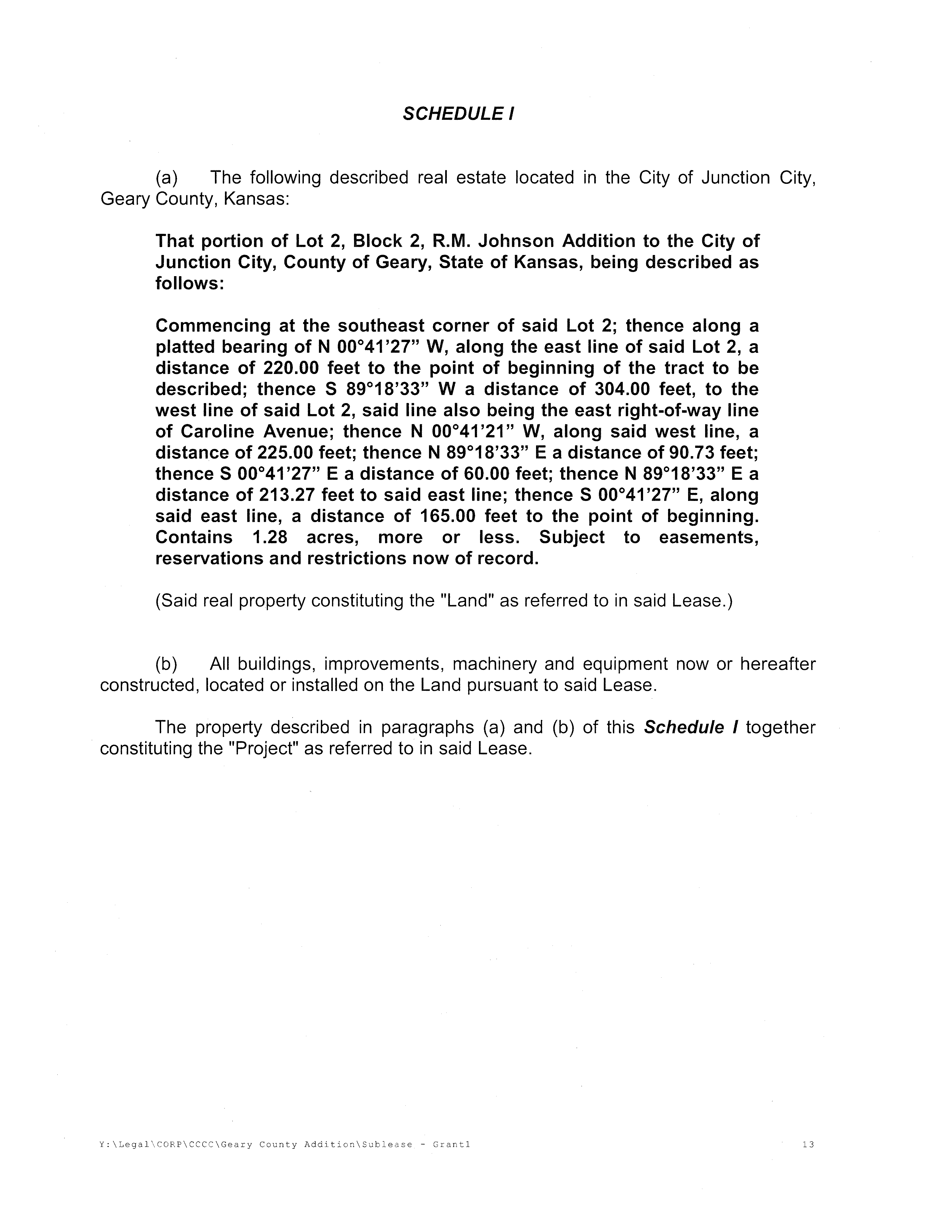

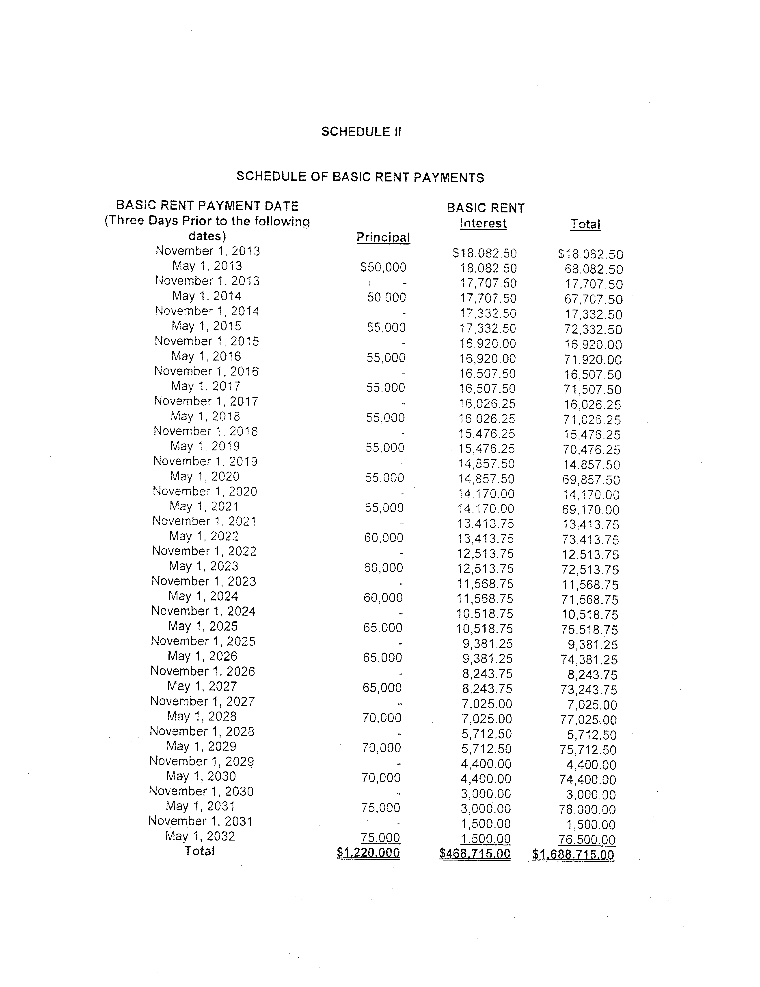

CLOUD COUNTY COMMUNITY COLLEGE
BOARD OF TRUSTEES
September 29, 2015

ITEM NO: 9

AGENDA ITEM: Other

ITEM TYPE:

COMMENT:

CLOUD COUNTY COMMUNITY COLLEGE
BOARD OF TRUSTEES
August 25, 2015

ITEM NO: 10

AGENDA ITEM: Executive Session

ITEM TYPE: Executive Session

COMMENT:

A. Consultation with Legal Counsel.

B. Non-elected Personnel.

C. Negotiations.

