BOARD OF TRUSTEES

CLOUD COUNTY COMMUNITY COLLEGE

DECEMBER 18, 2012

MISSION

Cloud County Community College is dedicated to delivering high quality, innovative, affordable, and accessible educational opportunities and services that prepare a diverse population to be critical thinkers and lifelong learners who can meet the challenges of an ever-changing global community.

To assure the delivery of this mission, Cloud County Community College is directed by valid and reliable assessment techniques, which measure the effectiveness and efficiency of all departments in the delivery of curriculum and services in support of student academic success.

VISION

Cloud County Community College strives to enrich the lives of our students and the communities we serve.

CLOUD COUNTY COMMUNITY COLLEGE
BOARD OF TRUSTEES

AGENDA - December 18, 2012

Meeting Place: Room 257 in the President’s Addition
Time: 7:00 p.m.

- Call to Order – 7:00 p.m.

2. Adopt Agenda Decision

3. Guests’ Comments

4. Recognitions Information . Information

5. Audit Decision

6. Program Highlights Information

7. President’s Message Information

8. Vice-President Reports Information

A. Vice President for Academic Affairs
B. Vice President for Administrative Services
C. Vice President for Enrollment Management and Student Services

9. Meeting Reports Information

10. Geary County Campus Update Information

11. Cloud County Community College Foundation Update Information

12. Approval of Minutes of November 27, 2012 Information

13. Finances Decision

A. Treasurer’s Report
B. Financial Overview
C. Residence Life Rates – 2013-2014

14. Purchasing and Payment of Claims Decision

15. Personnel Decision

- Retirement – Barbara Stevens
- Schedule President’s Evaluation
- Wellness
- Professional Development
- Other

CLOUD COUNTY COMMUNITY COLLEGE
BOARD OF TRUSTEES

Agenda - December 18, 2012

16. Facilities Decision

- Turbines
- Other

17. Policy F27 – Child Abuse Decision

18. Information Items Information

- Student Services Day – Geary County Campus
- Student Services Day – Concordia Campus
- First Day of Classes
- Youth for Music
- Induction into the Athletic Hall of Fame and Winter Homecoming
- 2013 Telefund

19. Other

20. Executive Session Executive Session

A. Consultation with Legal Counsel
B. Non-elected Personnel
C. Negotiations

NEXT MEETING – January 29, 2012

CLOUD COUNTY COMMUNITY COLLEGE
BOARD OF TRUSTEES
December 18, 2012

ITEM NO: 1

AGENDA ITEM: Call to Order – 7:00 p.m.

ITEM TYPE:

COMMENT:

CLOUD COUNTY COMMUNITY COLLEGE
BOARD OF TRUSTEES
December 18, 2012

ITEM NO: 2

AGENDA ITEM: Adopt Agenda

ITEM TYPE: Decision

COMMENT:

Parliamentary rules recommend the adoption of the Agenda.

RECOMMENDED ACTION:

Adopt the Agenda for the December 18, 2012 Board of Trustees meeting.

CLOUD COUNTY COMMUNITY COLLEGE
BOARD OF TRUSTEES
December 18, 2012

ITEM NO: 3

AGENDA ITEM: Guests’ Comments

ITEM TYPE:

COMMENT:

CLOUD COUNTY COMMUNITY COLLEGE
BOARD OF TRUSTEES
December 18, 2012

ITEM NO: 4

AGENDA ITEM: Recognitions

ITEM TYPE: Information

COMMENT:

CLOUD COUNTY COMMUNITY COLLEGE
BOARD OF TRUSTEES
December 18, 2012

ITEM NO: 5

AGENDA ITEM: 2011-2012 Audit

ITEM TYPE: Decision

COMMENT:

The final audit is enclosed. A representative from Jarrad, Gilmore and Phillips, P.A., will be present to answer any questions and for the acceptance of the audit.

RECOMMENDED ACTION:

Accept the 2011-2012 audit.

CLOUD COUNTY COMMUNITY COLLEGE
BOARD OF TRUSTEES
December 18, 2012

ITEM NO: 6

AGENDA ITEM: Program Highlights

ITEM TYPE: Information

COMMENT:

Kim Reynolds, Director of Admissions, will bring information regarding recruitment and the admissions process.

CLOUD COUNTY COMMUNITY COLLEGE
BOARD OF TRUSTEES
December 18, 2012

ITEM NO: 7

AGENDA ITEM: President’s Message

ITEM TYPE: Information

COMMENT:

CLOUD COUNTY COMMUNITY COLLEGE
BOARD OF TRUSTEES
December 18, 2012

ITEM NO: 8

AGENDA ITEM: Vice President Reports

ITEM TYPE: Information

COMMENT:

- Vice President for Academic Affairs.

- Vice President for Administrative Services.

- Vice President for Enrollment Management and Student Services.

CLOUD COUNTY COMMUNITY COLLEGE
BOARD OF TRUSTEES
December 18, 2012

ITEM NO: 9

AGENDA ITEM: Meeting Reports

ITEM TYPE: Information

COMMENT:

CLOUD COUNTY COMMUNITY COLLEGE
BOARD OF TRUSTEES
December 18, 2012

ITEM NO: 10

AGENDA ITEM: Geary County Campus Update

ITEM TYPE: Information

COMMENT:

A monthly report from the Geary County Campus is enclosed.

Geary County Campus
Report to the Board of Trustees
December 18, 2012
This report highlights the recent activities of the offices of the Campus Dean, Student Services, and Business and Industry Training:
Campus Activities – Brenda Edleston
- December has been a busy month conducting the Student Evaluations of Instruction. This evaluation tool is used to survey at least one class of every instructor. The questions are designed to ascertain the students’ opinions of their classroom experience. Faculty use the results of these surveys to make improvements in the way they instruct their course or improvements in the course itself.
- The Geary County Public Works Department recently had access to electrical power installed at the garage adjacent to the parking pad for the mobile science lab. This connection is needed to charge the multiple batteries that power the interior lights of the lab as well as to make the lab’s electrical outlets operational.
- GCC held its annual Christmas tree lighting ceremony and caroling on November 28. A nice crowd gathered to sing and enjoy refreshments. This event was sponsored by the Student Senate.
- Brenda Edleston met with representatives from the local workforce center about services for TRAC-7 program participants. Students enrolled in any of the TRAC-7 signature programs will register with the workforce center and complete a job interest survey called JobFit.
- The Geary County Public Works Department worked with LisaMarie Cheek and Brenda Edleston to clear the garage of broken furniture, unused and obsolete electronics and general debris.
- The Geary County Campus faculty and staff were joined by Dr. Kim Krull for a Christmas potluck luncheon and ornament exchange on December 13.
- The annual Christmas Door Decorating Contest showcased the talent and imagination of our students and staff. The judging was conducted by the members of Student Senate. The winning door is pictured here. The artist is student Cheryl Henderson.

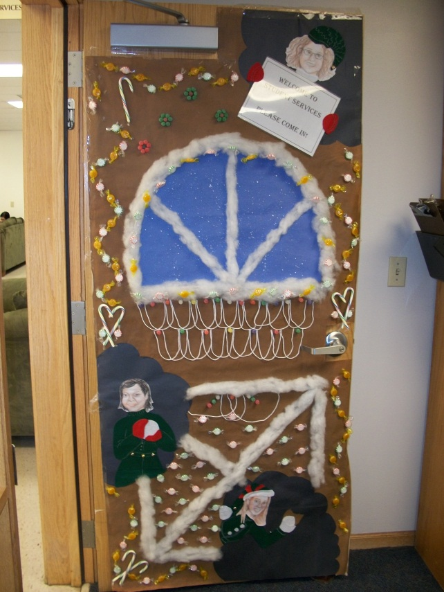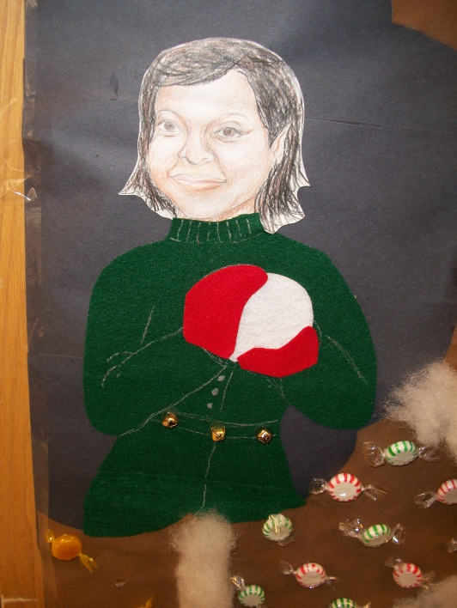

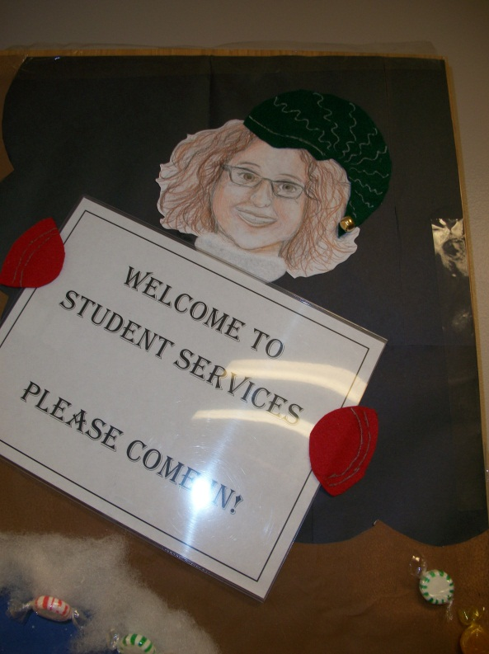

Student Services Activities – Jennifer Zabokrtsky
Recruitment/Admissions/Scholarships
- Miriam Melendez, Student Services Specialist/Military Affairs Liaison, administered the Compass placement test to 23 prospective students from November 19 to December 10.
- Miriam Melendez and Jennifer Zabokrtsky, Coordinator Student Services, met with Kim Reynolds, Director of Admissions, and Jenny Acree, Director of Marketing, November 30 regarding recruitment of Spring 2013 enrollees and recruitment of Fall 2013 prospective students.
- Jennifer Zabokrtsky administered the Compass placement test December 5 to five current CM 071 and CM 072 English as a Second Language (ESL) I and II students to determine placement in English courses for next semester.
- Brenda Edleston, Campus Dean, Cindy Lamberty, Instructor and Advisor, Cathy Castle, Instructor and Advisor, Miriam Melendez, and Jennifer Zabokrtsky met December 13 with Cloud County Community College Foundation staff to award Geary County Campus Foundation Scholarships for Spring 2013.
- Email and snail mail invitations will be sent to new Geary County Campus students before December 21 inviting them to attend New Student Orientation January 14 from 6-8 PM.
Military/Veterans
- The Geary County Campus has obtained its own facility code from the Veterans Administration (VA), which means students receiving the Post 9/11 GI Bill will receive their housing allowance based on the cost of living in Junction City rather than Concordia which will increase their benefit. Miriam Melendez and Patti Elliott have begun switching current students from the Concordia facility code to the Junction City facility code and have emailed all current VA students asking them to submit a change form to the VA.
- Patti Elliott, Cloud’s Veterans’ Rep, continues to travel to GCC on Thursdays to meet with student veterans and assist Miriam Melendez.
Enrollment/Advising/Transfer
- As of December 7, 270 students have enrolled on the Geary County Campus in 2,949 credit hours for the Spring 2013 semester. Faculty advisors will continue to enroll students during finals’ week and the week following finals, as well as the two weeks prior to the first day of classes January 15.
- Spencer Farha continues to travel to the Geary County Campus on Thursdays to meet with students on Academic Probation.
- Brenda Hanson was on campus November 29 to meet with students regarding career assessment, internship placement, and career planning.
- Joel Figgs was on campus December 7 to meet with Brenda Edleston, Jennifer Zabokrtsky, Miriam Melendez, and Laura Burgess regarding Student Services activities.
- Geary County Campus staff is meeting December 14 to plan staffing and set up for Student Services Day January 10.
Other Activities
- Jennifer Zabokrtsky and Miriam Melendez participated in mock interviews November 28 for students in Joan Robison’s HE 155 Parent, Providers, and Community Relationships class.
- Jennifer Zabokrtsky is a member of the Academic Calendar Committee which met November 28 to begin planning the 2013-2014 Academic Calendar.
- Jennifer Zabokrtsky is a member of the Foundation Executive Director Search Committee which met November 29.
Business and Industry Programs – Jason York
- Eight students participated in the CDL Phase I training sessions held November 16 and 17. One student utilized the Veteran’s Workforce Investment Program through the KansasWORKS program, and three different students took the program as preparation for transfer to Manhattan Area Technical College for their Electrical Power and Distribution Program. We also had two active-duty military students in the class. Our December 3-6 Phase 1 class had five students enrolled. One student utilized the Veteran’s Workforce Investment Program through the KansasWORKS program, and one student took the program as preparation for transfer to Manhattan Area Technical College for their Electrical Power and Distribution Program.
- CDL Phase II training (behind-the-wheel driving) is ongoing, and students are completing their driving examinations weekly at the Junction City DMV. Phase II is currently booked continuously with instructional driving and examinations at the Junction City DMV through the middle of January. Students who obtain their permits in the months of November and December will finish their training in January 2013.
- In cooperation with JoDee Aldridge-Ball, Coordinator of Allied Health, twelve students took the CNA state board exam on Wednesday, December 5. Twenty-three students started CNA Online-Hybrid courses on November 12. The next CNA Online-Hybrid training begins January 7, 2013; and we will be enrolling at least 20 students for that start date. Enrollment for the January CNA class will be December 17. The next CNA state board exam will be Wednesday, January 9; and we should have almost thirty students testing. We are actively recruiting instructors to teach CNA courses in the Geary County area.
- The Spring 2013 EMT Course is scheduled to be conducted January 18 through May 15.
- On Monday, December 17, the English as a Second Language program will be holding an orientation for their Basic ESL course. Students will take an assessment evaluation of their skills specific to reading, writing, listening, and speaking abilities. This is designed to help instructors evaluate which level of ESL their potential students will be placed and to help students feel more comfortable with the enrollment and registration process. There will be another ESL orientation on Monday, January 7.

CLOUD COUNTY COMMUNITY COLLEGE
BOARD OF TRUSTEES
December 18, 2012

ITEM NO: 11

AGENDA ITEM: Cloud County Community College Foundation Update

ITEM TYPE: Information

COMMENT:

A report from the Cloud County Community College Foundation will be presented.

CLOUD COUNTY COMMUNITY COLLEGE
BOARD OF TRUSTEES
December 18, 2012

ITEM NO: 12

AGENDA ITEM: Approval of Minutes of November 27, 2012

ITEM TYPE: Decision

COMMENT:

The minutes of the regular meeting of November 27, 2012 are enclosed.

RECOMMENDED ACTION:

Approve the minutes of November 27, 2012.

CLOUD COUNTY COMMUNITY COLLEGE
BOARD OF TRUSTEES
December 18, 2012

ITEM NO: 13

AGENDA ITEM: Finances

ITEM TYPE: Decision

COMMENT:

A. Treasurer’s Report and Financial Report. These reports are enclosed.

RECOMMENDED ACTION: Approve the Treasurer’s Report as of
November 30, 2012 with a cash balance of $3,977,504.26.

B. Financial Overview. The financial overview of the College as of the end of November will be presented.

C. Residence Life Rates 2013-2014. Enclosed are the proposed residence life rates for the 2013-2014 school year.

RECOMMENDED ACTION: Approve the recommended room and board rates for academic year 2013-2014.

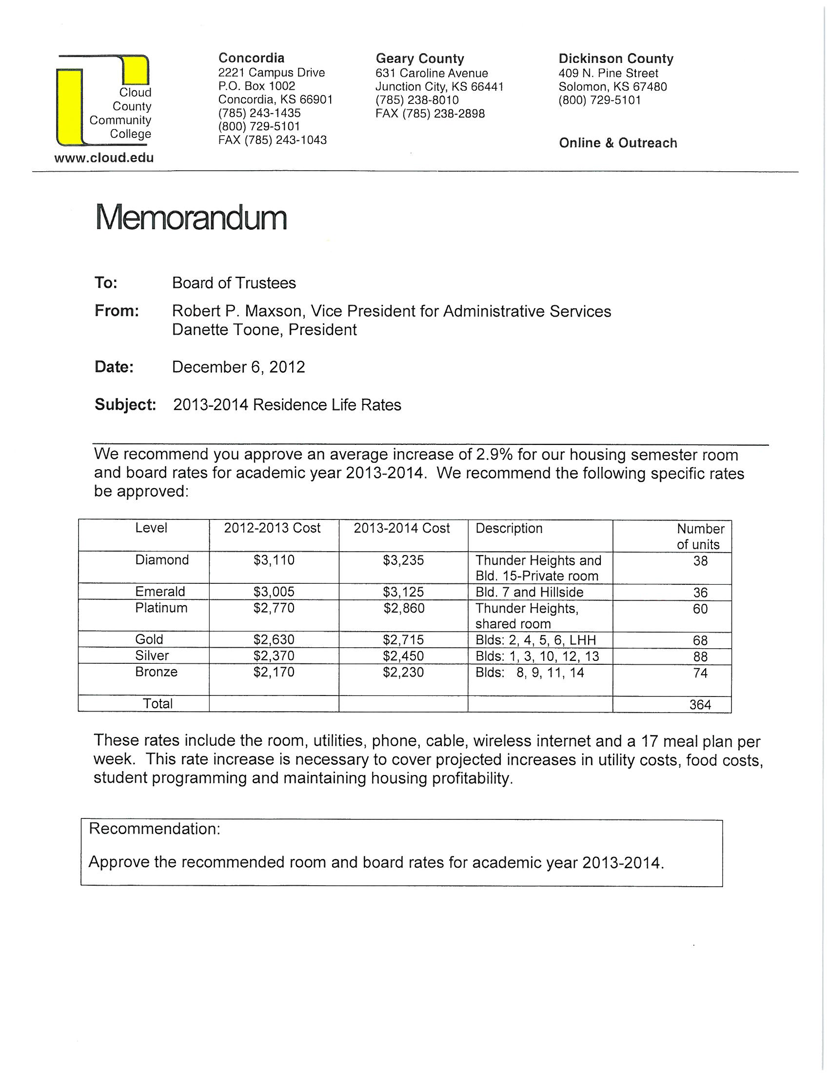

CLOUD COUNTY COMMUNITY COLLEGE
BOARD OF TRUSTEES
December 18, 2012

ITEM NO: 14

AGENDA ITEM: Purchasing and Payment of Claims

ITEM TYPE: Decision

COMMENT:

The purchase orders are enclosed or are available from the Clerk of the Board.

RECOMMENDED ACTION:

Approve the recommendations as stated.

CLOUD COUNTY COMMUNITY COLLEGE
BOARD OF TRUSTEES
December 18, 2012

(A) LIST
APPROVAL OF EXPENDITURES OR TRANSFERS OF COLLEGE FUNDS OVER $10,000.
This list contains requests for approval of expenditures or transfers of college funds over $10,000.
For some of the items listed, checks will be released prior to the next Board meeting and approval
of this list by the Board at this meeting will also authorize release of the checks. The other items,
orders will be prepared, and the payment of claims will be approved at the next Board meeting.

RECOMMENDED ACTION: Approve this list of expenditures or transfers of college funds over
$10,000.

CLOUD COUNTY COMMUNITY COLLEGE
BOARD OF TRUSTEES
December 18, 2012

ITEM NO: 15

AGENDA ITEM: Personnel

ITEM TYPE: Decision

COMMENT:

- Retirement – Barbara Stevens. Barbara Stevens submitted her request to participate in the Early Retirement Program effective May 17, 2013. She has been an employee of Cloud County Community College as an Instructor in Art since 2000. Her letter requesting participation in the Early Retirement Program is enclosed.

RECOMMENDED ACTION: Approve allowing Barbara Stevens to participate in the Early Retirement Program effective May 17, 2013 and authorize the administration to fill the Instructor in Art position vacancy.

B. Schedule President’s Evaluation. Policy AP-9 requires the President to be evaluated at a special meeting in the month of January.

RECOMMENDED ACTION: Schedule the Evaluation of the President at a special meeting in January.

C. Wellness. Cloud County Community College, in coordination with Blue Cross Blue Shield will be providing wellness activities. A Health and Wellness Survey is being conducted, and biometric screenings that will allow employees to evaluate their current state of health will be provided. On the In-service Day on January 11, a Fasting Blood Screening will be done by the Cloud County Health Center Laboratory Phlebotomists to test blood glucose and lipids. Results from the Fasting Blood Screening and Body Measurements can provide valuable information regarding the state of our health and wellness. It can be used as a tool for healthy lifestyle change. Incentives to be proactive with our health will be provided. We want to encourage employees to begin 2013 in a preventative fashion by participating in the CCCC Wellness Program. A healthy breakfast will be provided after the blood draw.

CLOUD COUNTY COMMUNITY COLLEGE
BOARD OF TRUSTEES
December 18, 2012

ITEM NO: 15

AGENDA ITEM: Personnel (Cont’d)

ITEM TYPE: Decision

COMMENT:

- Professional Development. Enclosed are the President’s Strategic Goals for 2012-2013 and the Professional Development Plan.

- Other.

Cloud County Community College
Office of the President
Strategic Goals for FY 2012-2013

ACCESS AND AFFORDABILITY
Expand educational opportunities to increase unduplicated headcount by 500 and credit hours by 5,000. Maintain tuition and fees at less than half of the average cost of attending Kansas’ public four-year institutions.

President’s Office Goal: Fine-tune the annual budget process, which includes controlling expenses, reallocating resources, and identifying/creating new sources of revenues, to include structured opportunity for each Department Chair/Director to explain and advocate for their budget, with all budgets tied to achieving the College’s Strategic Goals.
- Develop a timeline for the budget process, to include budget hearings and outcome communication, by January 31, 2013.
- Conduct budget hearings by May 15, 2013.

TEACHING AND STUDENT SUCCESS
Enhance academic excellence through rigor, relevance, relationship-building, innovative teaching and assessment. Increase the number of students who are graduating, transferring or completing an educational goal or credential by 25%.

President’s Office Goal: Provide a “corporate climate” that encourages innovation and empowers all employees to design more efficient work processes, utilize technology, and improve teaching and learning.
- Expand, through Professional Development Plan, opportunities for “best practice” group webinars and other such events. Research and offer one webinar a quarter, beginning January 2013.
- Full implementation of all Jenzabar modules purchased by June 30, 2013.

OUR PEOPLE
Recruit highly qualified and diverse employees passionate about the mission and annually retain at least 92% of its existing employees. Upgrade salaries, based on statewide average faculty salaries¹, to the 50th percentile of Kansas community colleges. On an annual basis, at least 95% of faculty and staff will participate in internal and/or external professional development opportunities.

President’s Office Goal: Implement a professional development plan, designed by faculty and staff, to enhance job skills, promote best practice knowledge and accomplishment, and encourage employee professional growth.
- Seek Board input by December 2012.
- Develop and implement sustainable budget by December 2012.
- Implement Plan by January 2013.
- Include individual Professional Development accomplishments into Evaluation instrument by June 30, 2013.

FACILITIES
Expand, maintain, enhance, and efficiently utilize facilities to meet growth expectations that enable the delivery of high quality, innovative, affordable, and accessible educational opportunities and services by increasing room utilization by 10%.

President’s Office Goal: Develop a Fleet Replacement Plan, approved by Board of Trustees, including a sustainable budget by October 30, 2012.

RESOURCES
Raise at least $5.7 million in cumulative gifts, institutional support, and grants to support the mission.

President’s Office Goal: Support Foundation and grant-writing opportunities so that $2 million new dollars are garnered for CCCC by June 30, 2013.

¹ The statewide average faculty salary calculation will exclude Kansas City Kansas Community College and Johnson County Community College.

CLOUD COUNTY COMMUNITY COLLEGE
BOARD OF TRUSTEES
December 18, 2012

ITEM NO: 16

AGENDA ITEM: Facilities

ITEM TYPE: Decision

COMMENT:

- Turbines.

- Other.

CLOUD COUNTY COMMUNITY COLLEGE
BOARD OF TRUSTEES
December 18, 2012

ITEM NO: 17

AGENDA ITEM: Policy F27 – Child Abuse

ITEM TYPE: Decision

COMMENT:

- Policy F27 – Child Abuse. The administration recommends the adoption of Policy F27 – Child Abuse. It was brought for your review at the November meeting and is brought to this meeting for approval. Changes have been made, and a revised copy of the proposed policy is enclosed.

RECOMMENDED ACTION: Approve Policy F27 – Child Abuse.

CLOUD COUNTY COMMUNITY COLLEGE

TOPIC: Policy Number
Child Abuse F27

Cloud County Community College maintains established procedures as they relate to the reporting of Child Abuse. The CCCC President or his/her designee has the authority to establish these procedures.

CLOUD COUNTY COMMUNITY COLLEGE

TOPIC: Policy Number
Child Abuse - Procedures F27

Purpose

The purpose of this policy is to comply with our moral obligation to protect minor children as vulnerable members of society. Specifically, this policy addresses the reporting of abuse of minor children as mandated by Kansas Statute 38-2223. This statute addresses the reporting of certain abuse or neglect of children, persons reporting, reports made to whom, penalties, and immunity from liability.

Definition of Abuse

Physical, mental, or emotional abuse of a minor child means the infliction of physical, mental, or emotional harm or the causing of a deterioration of a child and may include, but shall not be limited to, maltreatment or exploiting a child to the extent that the child’s health or emotional well-being is endangered. Sexual abuse includes contacts or interactions between a child and an adult when the child is being used as an object of sexual gratification for the adult, the child, or another person. A child may be sexually abused whether or not the activity involves explicit force, involves genital or physical contact, is initiated by the child, or has a discernible harmful outcome.

Kansas Law

Kansas law provides that anyone who has reason to suspect that a child has been abused or neglected may report the abuse or neglect, without malice, and receive immunity from liability for making such a report. In order to protect our students or other minor children, under the age of 18, these procedures require our staff to report child abuse that allegedly occurs on our campus property or in vehicles owned or leased by the college; or while members of the faculty, staff and study body are participating in a college connected activity or event regardless of its location.

College Personnel/College Student Responsibility

Any college employee or student who has reason to believe that a minor has been abused on the college campus; on property or in vehicles owned or leased by the college; or while members of the faculty, staff, or student body are participating in a college connected activity or event or who has received a report of such alleged abuse shall report this information by contacting the Kansas Department for Children and Families at (800)922-5330. The willful and knowing failure to make a report required by this section is a class B misdemeanor. It is not a defense that another mandatory reporter made a report. Intentionally preventing or interfering with the making of a report required by this section is a class B misdemeanor.

CLOUD COUNTY COMMUNITY COLLEGE
BOARD OF TRUSTEES
December 18, 2012

ITEM NO: 18

AGENDA ITEM: Information Items

ITEM TYPE: Information

COMMENT:

- Student Services Day – Geary County Campus. Student Services Day on the Geary County Campus will be January 10, 2013.

- Student Services Day – Concordia Campus. Student Services Day on the Concordia Campus will be January 14, 2013.

- First Day of Classes. The first day of classes for the Spring 2013 semester will be January 15, 2013.

- Youth for Music. The 43rd Annual Youth for Music sponsored by Cloud County Community College and Tom’s Music House will be held January 26-27, 2013. Rehearsals will take place on Saturday, January 26; and more than 300 area high school students will perform either in the band of one of the two choirs on Sunday, January 26.

- Induction into the Athletic Hall of Fame and Winter Homecoming. The 2013 Induction into the Athletic Hall of Fame and Winter Homecoming will be held Saturday January 26, 2013. The men’s and women’s basketball teams will be playing Hutchinson Community College that evening.

- 2013 Telefund. The 2013 Cloud County Community College Foundation Telefund will begin January 27, 2013.
CLOUD COUNTY COMMUNITY COLLEGE
BOARD OF TRUSTEES
December 18, 2012

ITEM NO: 19

AGENDA ITEM: Other

ITEM TYPE:

COMMENT:

CLOUD COUNTY COMMUNITY COLLEGE
BOARD OF TRUSTEES
December 18, 2012

ITEM NO: 20

AGENDA ITEM: Executive Session

ITEM TYPE: Executive Session

COMMENT:

- Consultation with Legal Counsel.

- Non-elected Personnel.

- Negotiations.

